* **The Law of Total Probability - Practice**

【TP】The paper “Action Bias among Elite Soccer Goalkeepers: The Case of Penalty Kicks” (Journal of Economic Psychology [2007]: 606–621) presents an interesting analysis of 286 penalty kicks in televised championship soccer games from around the world. In a penalty kick, the only players involved are the kicker and the goalkeeper from the opposing team. The kicker tries to kick a ball into the goal from a point located 11 meters away. The goalkeeper tries to block the ball from reaching the goal. For each penalty kick analyzed, the researchers recorded the direction that the goalkeeper moved (jumped to the left, stayed in the center, or jumped to the right) and whether or not the penalty kick was successfully blocked. Consider the following events:

L = the event that the goalkeeper jumps to the left

C = the event that the goalkeeper stays in the center

R = the event that the goalkeeper jumps to the right

B = the event that the penalty kick is blocked

Based on their analysis of the penalty kicks, the authors of the paper gave the following probability estimates:

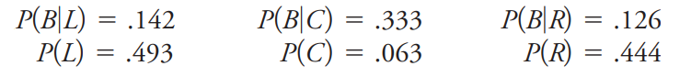

What proportion of penalty kicks were blocked?

* **Bayes’ Rule**

If B1 and B2 are ____________ events with ______________________ , then for any event E

P(B1|E) =

Generally, if B1, B2, … , Bk are ____________ events with ___________________________ , then for any event E:

P(Bi|E) =

* **Practice:**

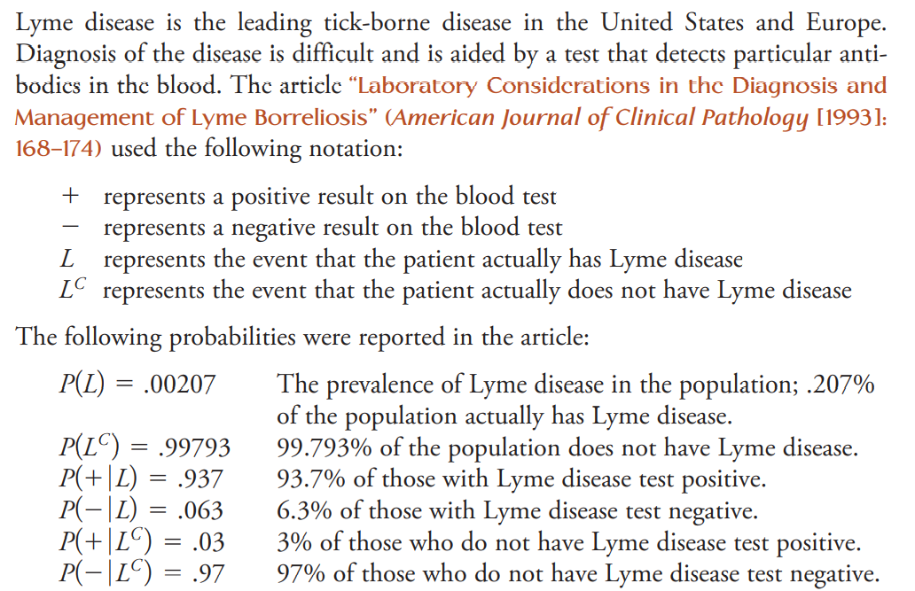Given that a person tests positive for the disease, what is the probability that he or she actually has Lyme disease?

* **Independence**
* **Def:** Two events (A & B) are independent if _________________________________________________
* P(A|B) = ___________ P(B|A) =

$P(A∩B) = P(A)*P(B)$

 ___________________
* Independent vs. Mutually Exclusive

**Venn Diagram**

Independent events A & B Mutually exclusive events A & B

P(A|B) = __________________ P(A|B) = __________________

* **Homework:**

The article “SUVs Score Low in New Federal Roll over Ratings” (San Luis Obispo Tribune, January 6, 2001) gave information on death rates for various kinds of accidents by vehicle type for accidents reported to the police. Suppose that we randomly select an accident reported to the police and consider the following events:

R = event that the selected accident is a single-vehicle rollover,

F = event that the selected accident is a frontal collision,

D = event that the selected accident results in a death.

Information in the article indicates that the following probability estimates are reasonable:

P(R) = .06, P(F) = .60, P(R|D) = .30, P(F|D) = .54.

a. Interpret the value of P(R|D)

b. Are the events R and D independent? Justify your answer.

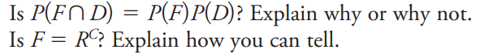c.

d.